Code # BU03 (2014)
Bulletin Change Transmittal Form
☒ Undergraduate Curriculum Council - Print 1 copy for signatures and save 1 electronic copy.
☐ Graduate Council - Print 1 copy for signatures and send 1 electronic copy to pheath@astate.edu
Bulletin Change
Please attach a copy of all catalogue pages requiring editorial changes.
Jollean Sinclaire 9/24/2014  Department Curriculum Committee Chair | ___________________ Enter date…  COPE Chair (if applicable)
___________________ Enter date…  Department Chair: | ___________________ Enter date…  General Education Committee Chair (If applicable)
___________________ Enter date…  College Curriculum Committee Chair | ___________________ Enter date…  Undergraduate Curriculum Council Chair
___________________ Enter date…  College Dean | ___________________ Enter date…  Graduate Curriculum Committee Chair
___________________ Enter date…
Vice Chancellor for Academic Affairs

1.Contact Person (Name, Email Address, Phone Number)
Jollean Sinclaire, ASU / CIT Department, Box 130, State University, AR 72467 jsinclaire@astate.edu (870) 972-3416

2.Proposed Change
Associate of Science in Computer and Information Technology: Require “C” or better for all Major Requirements

3.Effective Date
Immediately

4.Justification
This change aligns requirements for the major for AS and BS degrees. Currently, “C” or better is required for all major requirements in the BS degree. This change makes the “C” or better requirement for all courses in the major consistent in both programs.

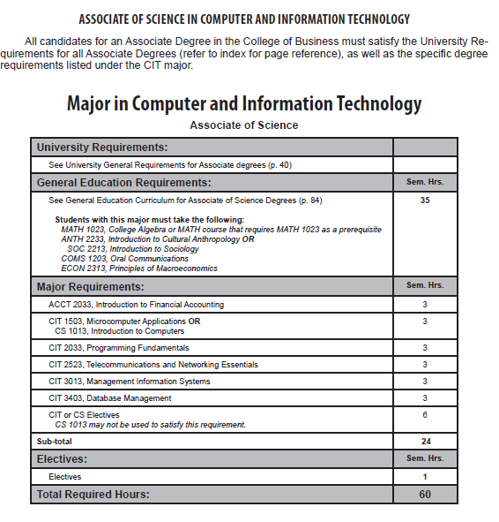
Page 140

Current page 140:

Change highlighted section to:

